Recreation Grant Program Application

Part I – Applicant Information

Applicant/Sponsoring entity, municipality or non-profit organization:

Brief organizational overview, (1-2 sentences):

Applicant Contact Person/Title:

Applicant’s Mailing Address:

Applicant’s Telephone and Email:

Part II – Grant Reporting

Prior Grants: Did the Applicant receive a grant award last year? If so, briefly summarize your completed project and attach a photo (or video) that captures the essence of your project.

Part III- Project Information
- Project Name:

- Project Location:

- Total Project Cost:

- Matching Funds and/or In-kind Donations/Labor:

- Amount Requested:

- Detailed Description of Proposed Project:
- Please note if this is a new initiative, a continuation of a past project, or recurring need/program which requires annual funding.

- Project Justification:
- How does this project improve recreational opportunities for the public?
- What makes this project a significant recreational priority for the Mad River Valley?
- Why is this project needed; Why it is important to be funded?

8) Project Readiness: What is the status of the project? List any major activities that must still be accomplished before the project can begin such as permitting, engineering, or fundraising. (Note that funds are expected to be used within the same calendar year, unless a waiver is granted.)

9) Target Audience: Describe the range of users this project will serve; Tell how this project will improve access and capacity for people of various ages (young children – older citizens) or abilities to access recreation.

10) Project Sustainability: If a grant is awarded for this project, who will manage and maintain the trail/facility/equipment/program once the work is done and grant funds are spent? What is the applicant’s commitment for continued operation and maintenance? List financial, community & organizational support in place for longevity of the project and general upkeep to ensure the useful life of the project.

11) Promoting Awareness of Project: What measures are in place to make the public more aware of the recreation opportunities this project provides, and encourage broader participation in recreation as well as opportunities for volunteerism with the organization?

12) Community collaboration, Local Support & Involvement: Who supports this project? Describe if this project connects to any other community projects, organizations or events. Describe local citizen and community involvement in the proposed project, and local support obtained for project implementation. Identify support or assistance needed

13) Measuring success: Describe how you will measure the impact of this project. What will success look like?

14) Environmental Impact Considerations: Are there any potential environmental impacts associated with this project? Describe these considerations and practices that will be used to ensure sustainability, minimize impacts such as water quality or soil erosion. For trail projects, see http://fpr.vermont.gov/recreation/learn_more for a list of suggested resources.

Part IV- Project Budget-
Applicants must attach a project budget which includes sources of revenue as well as expenses. Please attach your overall organizational budget if possible.

Required Certifying Signature-
By signing below, I hereby certify that the information in the Recreational Grant Application is true
and accurate to the best of my knowledge. I have full authority to submit this application and seek funds through the MRVRD for the work proposed in this application.
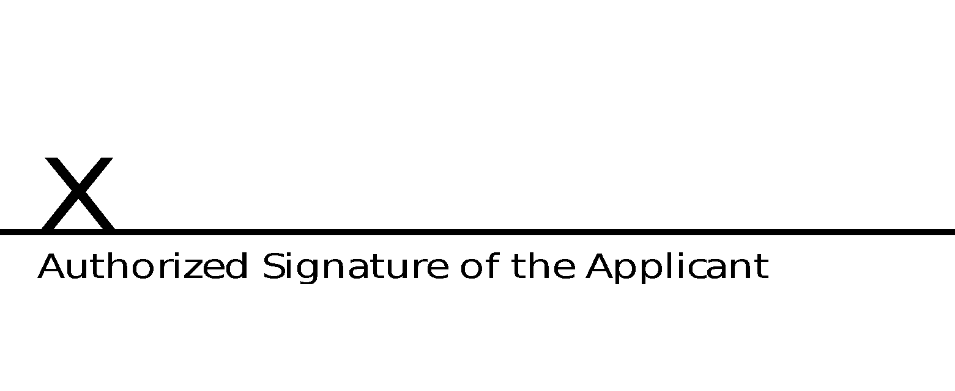
Submit completed application by email to mrvrd@mrvrd.org

